**Data Manipulation Language**

**DML Commands in Hive**

DML (Data Manipulation Language) commands in Hive are used for inserting and querying the data from hive tables once the structure and architecture of the database has been defined using the DDL commands listed above.

Data can be loaded into Hive tables using –

* LOAD command
* Insert command

**Usage of LOAD Command for Inserting Data Into Hive Tables**

**Syntax for Load Command in Hive**

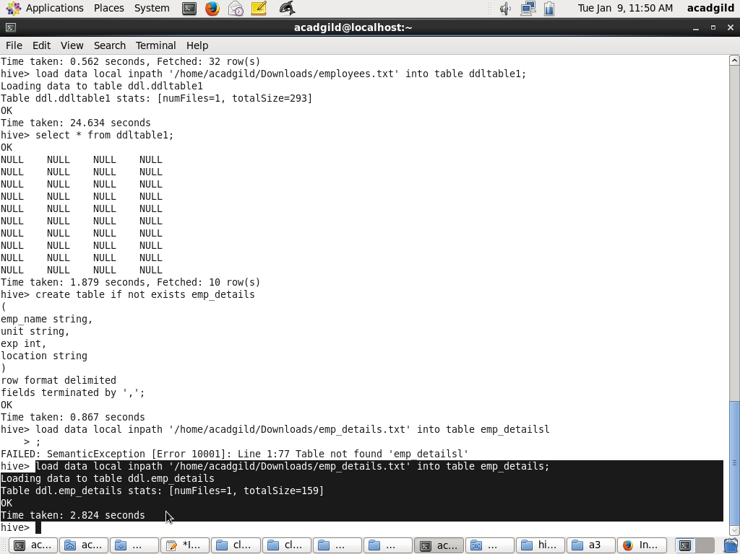

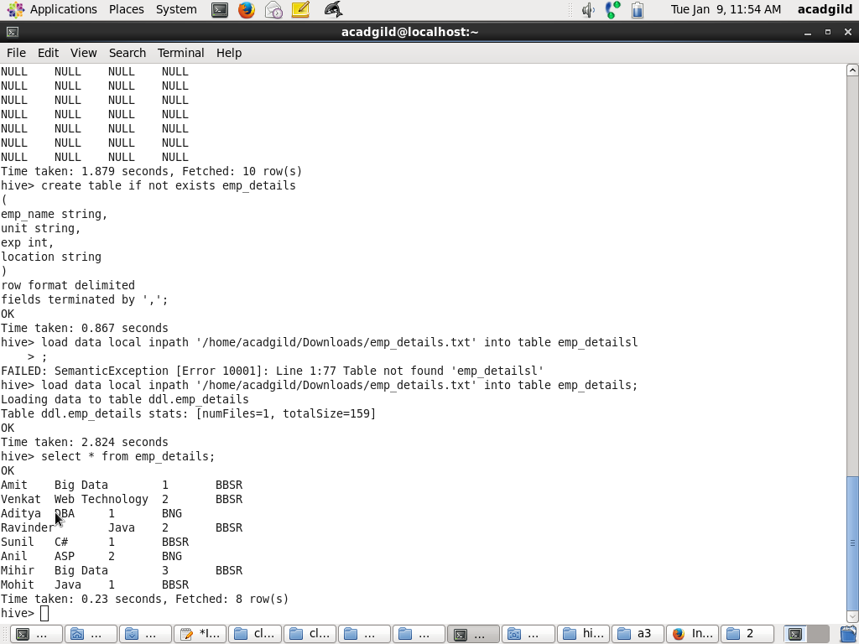

If the keyword LOCAL is not specified, then Hive will need absolute URI of the file. However, if local is specified then it assumes the following rules -

* It will assume it’s an HDFS path and will try to search for the file in HDFS.
* If the path is not absolute, then hive will try to locate the file in the /user/ in HDFS.

### Inserting data into Hive Tables from queries

Query Results can be inserted into tables by using the insert clause.

